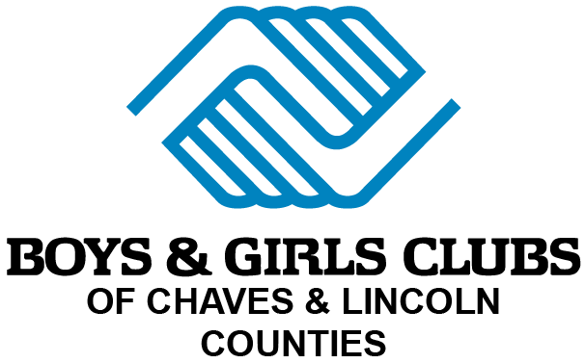
134 Reese Drive
Ruidoso, NM 88345
(575) 454-7100

www.bgcclc.org
201 S Garden
Roswell, NM 88203
(575) 550-5001

www.bgcclc.org

VOLUNTEER APPLICATION
PLEASE READ BEFORE COMPLETING APPLICATION
This association does not discriminate in the recruitment, training, and conditions of volunteer service on the basis of race, color, religion, national origin, sex, marital status, disability, age, or veteran status. No question on this application is intended to secure information to be used in a discriminatory manner. Your completed application will be reviewed carefully but its receipt does not imply that you will be accepted as a volunteer. Consideration necessitates that you meet all the qualifications required for the position for which you are applying.

PERSONAL DATA
Name ______________________________________ Date ___________
First Middle Initial Last
Address _______________________________________________
Street City, State Zip
Telephone: Home ___________ Mobile ___________
Email _______________________________________________
Are you 18 years of age, or over? Yes ___ No ___
Are you authorized to volunteer in the United States? Yes ___ No ___
Other names used (maiden, prior, etc.): ______________________________

GENERAL INFORMATION
Volunteer position(s) or area(s) of interest: _______________________________
Preferred location: __________________________
Date available to begin volunteering: __________________________
Days/times available: _________________________________________
Have you previously applied to volunteer at the Boys & Girls Clubs of Chaves & Lincoln Counties? Yes ___ No ___
If so, when? ____________________ Location _______________________
Have you volunteered for another Boys & Girls Club organization? Yes ___ No ___
If yes, when and where? ________________________________________
Have you ever been asked to leave or dismissed from a volunteer or employment position? Yes ___ No ___
If yes, please explain: ___________________________________________

VOLUNTEER AND WORK EXPERIENCE
List your current or most recent volunteer or work experience.
Organization _______________________________________________
Role/Title ________________________________________________
Dates of Service From __________ To __________
Supervisor’s Name ________________________________________
Phone/Email _____________________________________________
Briefly describe your responsibilities: ______________________________
Did you work with children? Yes ___ No ___
If yes, please describe: ___________________________________________
Number of children: __________ Age group: __________
Any experience supervising others? Yes ___ No ___ If yes, please describe: __________________________

EDUCATION
High School ______________________________________ Graduated? Yes ___ No ___
College __________________________________________ Degree ____________________
Other training, certifications, or licenses (CPR, First Aid, etc.): _____________________________

SPECIAL SKILLS OR QUALIFICATIONS
Summarize special skills and qualifications you have acquired from employment, previous volunteer work, or through other activities, including hobbies or sports, that may be helpful for volunteer service:
_________________________________________________________________________

POSITION ON THE NATION-WIDE PROBLEM OF CHILD ABUSE
The Boys & Girls Clubs of Chaves & Lincoln Counties endorses and enforces policies and practices to prevent child abuse. Our first priority in all youth programs is care and safety. We actively work to prevent verbal, physical, emotional, or sexual abuse.
Our goals are:
- To support and strengthen the family unit.
- To help children develop to their fullest potential.
- To deliver programs in a safe, supportive, and caring environment.
Allegations or suspicions of child abuse are taken seriously and reported to the State for investigation. The organization fully cooperates with investigations and supports prosecution to the fullest extent under the law. All volunteers are subject to background screening, including but not limited to references, criminal records, and volunteer history.

VOLUNTEER CODE OF ETHICS
As a volunteer of the Boys & Girls Clubs of Chaves & Lincoln Counties, I agree to:
- Not verbally, physically, emotionally, or sexually abuse a child.
- Not be alone with children except with prior approval or in an emergency.
- Use appropriate language and demonstrate positive behavior.
- Refrain from giving or accepting gifts or money from program participants.
- Avoid socializing or providing services to youth outside of Club activities without prior approval.
- Report any suspected child abuse or neglect to appropriate authorities immediately.
- Serve as a positive role model for children by demonstrating respect, patience, and maturity.
- Treat all children and youth with kindness, respect, and fairness.
- Use only positive techniques of guidance and discipline.
- Not use or possess alcohol, illegal drugs, or tobacco while volunteering.
- Maintain proper personal hygiene and dress appropriately for volunteer service.
I have read and understand the Boys & Girls Clubs of Chaves & Lincoln Counties’ policies on child abuse prevention and this Code of Ethics. I understand that violation of these policies may result in termination of my volunteer service.

BACKGROUND INFORMATION
All volunteers are required to undergo a criminal background screening. A conviction does not necessarily disqualify you. Please answer honestly.
Have you ever been convicted of, or pleaded guilty or 'no contest' to, a criminal offense?
Yes ___ No ___
If yes, please provide dates and details: ___________________________________________
Have you ever been accused of child abuse or neglect? Yes ___ No ___
If yes, please explain: ___________________________________________

VOLUNTEER INTERESTS AND MOTIVATION
Why do you want to volunteer with the Boys & Girls Clubs of Chaves & Lincoln Counties?
_____________________________________________________________
What age group or program are you most interested in helping with?
_____________________________________________________________
What strengths do you bring to this volunteer experience?
_____________________________________________________________
What challenges do you anticipate?
_____________________________________________________________

PERSONAL REFERENCES
List four personal references (not employers). Must include at least one relative, one male, and one female.
1. Name _______________________ Phone ___________ Relationship ___________ Years Known ____
2. Name _______________________ Phone ___________ Relationship ___________ Years Known ____
3. Name _______________________ Phone ___________ Relationship ___________ Years Known ____
4. Name _______________________ Phone ___________ Relationship ___________ Years Known ____

VOLUNTEER AGREEMENT & CERTIFICATION
I certify that the information provided on this application is true and complete to the best of my knowledge. I authorize the Boys & Girls Clubs of Chaves & Lincoln Counties to verify all information and conduct background checks as necessary.
I understand that submission of this application does not guarantee acceptance as a volunteer. If accepted, I agree to comply with all rules, regulations, and policies of the organization. I also understand that volunteer service is not employment, and may be terminated at any time by either party.
I have read, understand, and support the Boys & Girls Clubs of Chaves & Lincoln Counties’ position on the prevention of child abuse and its Volunteer Code of Ethics.
Signature of Applicant ______________________________ Date _______________
Printed Name ______________________________________

